SEO tips for images
Search engines offer us their ways of finding the information. Every time you press the ‘enter’ you see results below the search string and there is a column among them which provides you with pictures that are referred to the theme. It can be found in the right corner in Google:
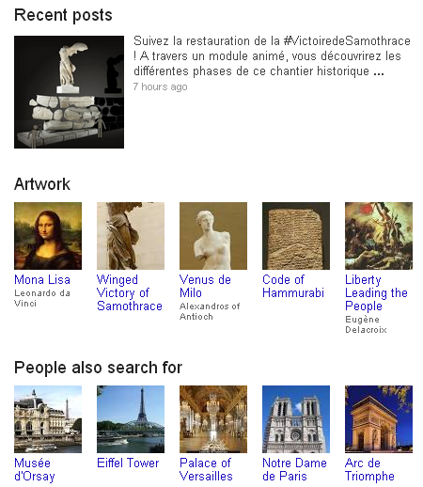
or in the middle of the results, as it is in Yandex:
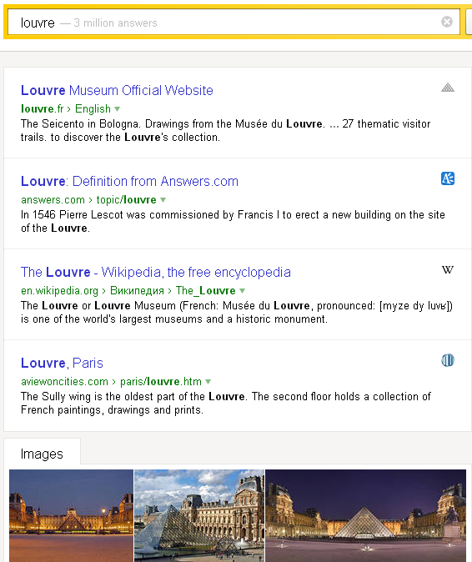

Of course, mechanism of general search is much better and more efficient, but image search is not an odd thing. Moreover, there is a number of websites that have the main aim: to supply their users with pictures. Then you should start on the optimization of them. It is quite easy and very useful! To be sure, check out these points:
- The first point of optimization is alt attribute. Sometimes browser does not depict an image. This function can be just switched off, in cases when you have mobile Internet or bad connection. There are many others reasons, but let’s clarify… Alt attribute is a feature which allows user to read the information of the picture without its representation. It’s matter of the keywords that are, in fact, the core of the alt attribute.
- Size of the picture figures too. If you have bigger image than others, there’s more probability that it will be defined by the search engine as the original source.
- Image is supposed to have keyword in title attribute, one more function to help you with optimization. Its content usually looks like a tooltip, all you need is to direct the mouse cursor on the image. It works almost with all primary browsers.
- Presence of keywords in surrounding text also plays a significant role. Pay attention that image ranking depends on keywords that are in the text below the picture, not under. Also, it’s better to write keywords in the first passage.
- Name of the image should have transliterated or translated keywords, but the first method is more effective because nowadays Google and Yandex are able to identify transliteration.
- PageRank have influence on classification of images. PR is a link analysis algorithm which was created with the purpose of ‘measuring’ relative importance of page. It was created by Google. There is analog system in Yandex, it’s called Thematic Index of Quotation.
- One of the main factors in promotion of images is anchor element. Actually, it’s just a text of link. When users view the web page in a browser, they can click the text to activate the link and visit the page whose URL is in the link. In most graphical browsers, when the cursor hovers over a link, the cursor changes into a hand with a stretched index finger and the title is displayed in a tooltip or in some other manner. Some browsers render alt text the same way, despite this not being what the specification calls for.
Well, as you can see, these methods don’t demand many efforts. Just remember these tips to accomplish image optimization within the framework of inner website optimization. Good luck!

